**ES Lab 5 Report**

**Programs on Sorting**

Date: 5th February, 2025

Phirozgar Irani

230905370

CSE 4B: B2

Q1. Write an assembly program to sort an array using selection sort.

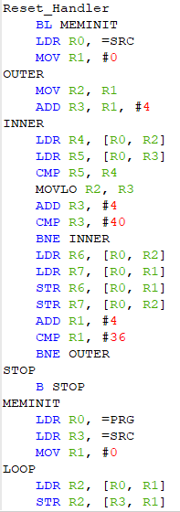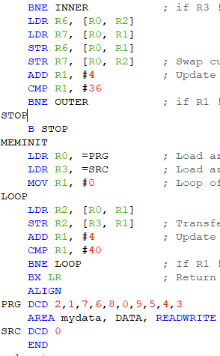

Q2. Write an assembly program to find the factorial of an unsigned number using

recursion

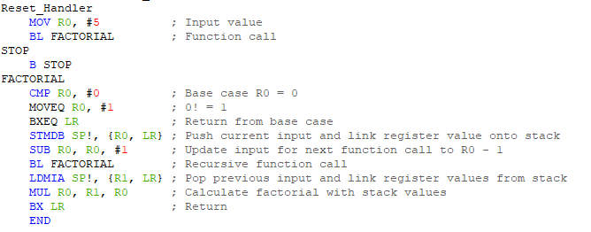

Q3. Assume that ten 32-bit numbers are stored in registers R1-R10. Sort these numbers

in the empty ascending stack using selection sort and store the sorted array back

into the registers. Use STM and LDMDB instructions wherever necessary

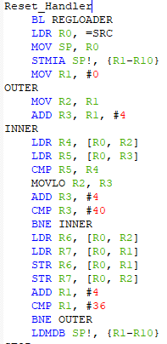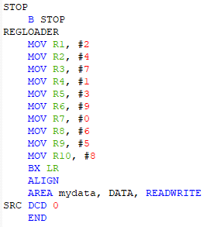

Q4. Repeat question 3 for a fully descending stack using STMDB and LDM

instruction wherever necessary.

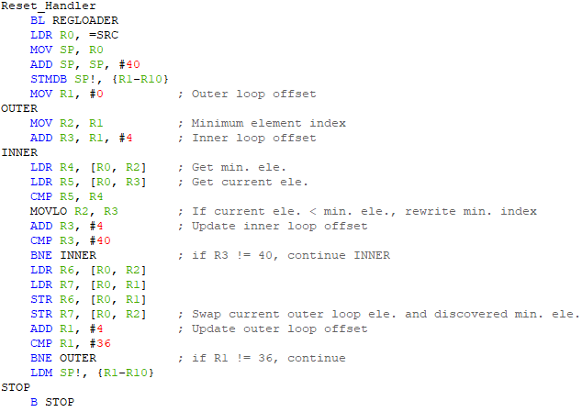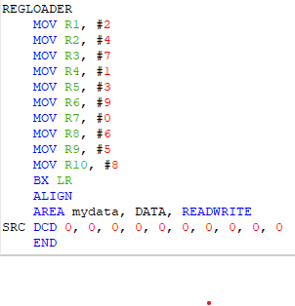

Q5. Write an ARM ALP that contains a list of numbers and makes a count of

Even and Odd numbers.

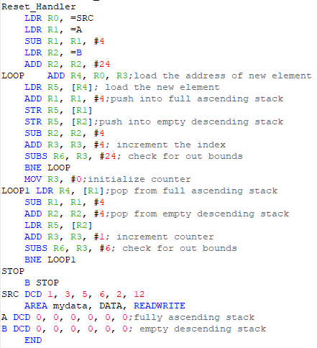

Q6. Implement Full ascending and empty descending stack using LDR, STR, ADD

and SUB instructions.

